ADVANCED JAVA TECHNOLOGIES

PRACTICAL NO: 1
1 a) Create a simple calculator application using servlet.

index.htdml
<html>
<body>
<form method="post" action="CalcServlet">
NO-1 <input type="text" name="t1">
NO-2 <input type="text" name="t2"> <br><br>
<input type="submit" value="+" name="btn">
<input type="submit" value="-" name="btn">
<input type="submit" value="*" name="btn">
<input type="submit" value="/" name="btn">
</form>
</body>
</html>
CalcServlet.java
import java.io.*;
import javax.servlet.*;
import javax.servlet.annotation.WebServlet;
import javax.servlet.http.*;
import javax.servlet.http.HttpServletResponse;

@WebServlet("/CalcServlet")
public class CalcServlet extends HttpServlet {
public void doPost(HttpServletRequest request, HttpServletResponse response) throws ServletException, IOException {
response.setContentType("text/html");
PrintWriter out = response.getWriter();
int a = Integer.parseInt(request.getParameter("t1"));
int b = Integer.parseInt(request.getParameter("t2"));
int c = 0;
String op = request.getParameter("btn");

if (op.equals("+"))
c = a + b;
else if (op.equals("-"))
c = a - b;
else if (op.equals("*"))
c = a * b;
else if (op.equals("/"))
c = a / b;
out.println("<b>" + a + op + b + " = " + c + "<b>");
}
}
OUTPUT:
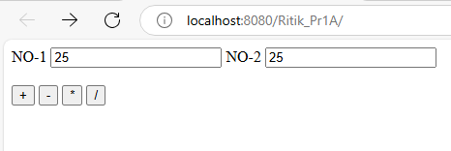
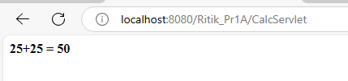
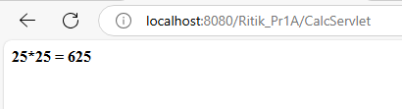
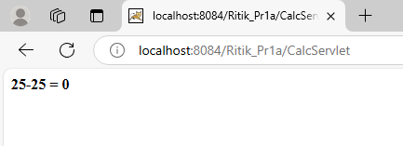
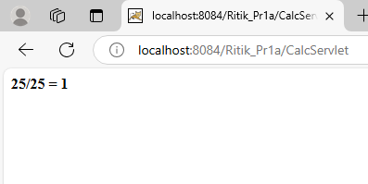
1 B) Create a servlet for a login page. If the username and password are correct then it says message “Hello ” else a message “login failed”.

index.html
<html>
<head>
<title>Login Form</title>
</head>
<body>
<form action="LoginServlet" method="get">
Enter User ID: <input type="text" name="txtId"><br>
Enter Password: <input type="password" name="txtPass"><br>
<input type="reset">
<input type="submit" value="Click to Login">
</form>
</body>
</html>

LoginServlet.java
import java.io.*;
import javax.servlet.ServletException;
import javax.servlet.http.*;
@WebServlet("/LoginServlet")
public class LoginServlet extends HttpServlet {
public void doGet(HttpServletRequest request, HttpServletResponse response)
throws ServletException, IOException {

response.setContentType("text/html;charset=UTF-8");
PrintWriter out = response.getWriter();

out.println("<html><head><title>Servlet LoginServlet</title></head>");

String uname = request.getParameter("txtId");
String upass = request.getParameter("txtPass");

if (uname.equals("Ritik") && upass.equals("12345")) {
out.println("<body bgcolor='yellow'>");
out.println("<h1> Welcome !!! " + uname + "</h1>");
} else {
out.println("<body bgcolor='red'>");
out.println("<h1> Login Fail !!! </h1>");
}

out.println("</body></html>");
}
}
OUTPUT:

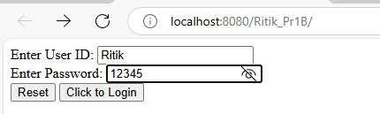

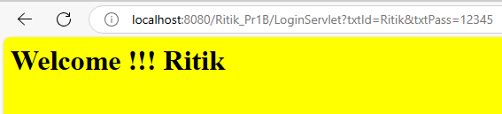

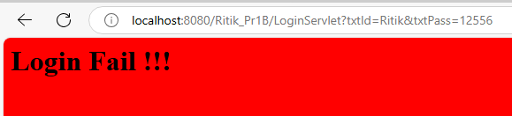

1C) Create a registration servlet in Java using JDBC. Accept the details such as Username, Password, Email, and Country from the user using HTML Form and store the registration details in the database.

<html>
<body>
<form action="RegistrationServlet" method="post">
User name: <input type="text" name="uname"><br>
Password: <input type="password" name="pw"><br>
Email Id: <input type="text" name="email"><br>
Country:
<select name="coun">
<option>select...</option>
<option>India</option>
<option>Bangladesh</option>
<option>Bhutan</option>
<option>Canada</option>
</select><br>
<input type="submit" value="Register">
</form>
</body>
</html>
RegistrationServlet.java
import java.io.*;
import java.sql.*;
import javax.servlet.*;
import javax.servlet.http.*;

public class RegistrationServlet extends HttpServlet {
public void doPost(HttpServletRequest request, HttpServletResponse response) throws IOException, ServletException {
Connection con = null;
PreparedStatement ps = null;
response.setContentType("text/html");
PrintWriter out = response.getWriter();

String username = request.getParameter("uname");
String password = request.getParameter("pw");
String emailid = request.getParameter("email");
String country = request.getParameter("coun");
try {
Class.forName("com.mysql.jdbc.Driver");
con = DriverManager.getConnection("jdbc:mysql://localhost:3306/registerdb", "root", "tiger");
out.println("Connection done successfully...");

ps = con.prepareStatement("INSERT INTO user VALUES (?, ?, ?, ?)");
ps.setString(1, username);
ps.setString(2, password);
ps.setString(3, emailid);
ps.setString(4, country);
ps.execute();

out.print("Data inserted successfully!!!!");
} catch (Exception e) {
out.println(e);
}
out.println("<b>" + "<b>");
}
}
OUTPUT:
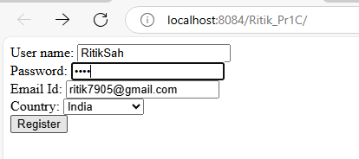
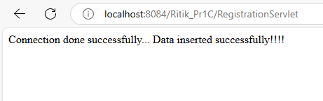
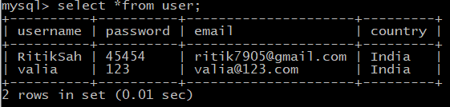

PRACTICAL NO: 2
2 a) Using Request Dispatcher Interface create a Servlet which will validate the password entered by the user, if the user has entered "Servlet" as password, then he will be forwarded to Welcome Servlet else the user will stay on the index.html page and an error message will be displayed.

Index.html
<html>
<body>
<form method="post" action="ValidateServlet">
User Name: <input type="text" name="un"><br>
Password: <input type="password" name="pw"><br>
<input type="submit" value="Login">
</form>
</body>
</html>

ValidateServlet.java

import java.io.*;
import javax.servlet.*;
import javax.servlet.http.*;

public class ValidateServlet extends HttpServlet {
public void doPost(HttpServletRequest req, HttpServletResponse res) throws IOException, ServletException {
res.setContentType("text/html");
PrintWriter out = res.getWriter();

String username = req.getParameter("un");
String password = req.getParameter("pw");

if (password.equals("Servlet")) {
req.setAttribute("s1username", username);
req.setAttribute("s1password", password);
RequestDispatcher rd = req.getRequestDispatcher("/WelcomeServlet");
rd.forward(req, res);
} else {
out.print("Incorrect password");
RequestDispatcher rd = req.getRequestDispatcher("/index.html");
rd.include(req, res);
}
}
}

WelcomeServlet.java

import java.io.*;
import javax.servlet.*;
import javax.servlet.http.*;

public class WelcomeServlet extends HttpServlet {
public void doPost(HttpServletRequest req, HttpServletResponse res) throws ServletException, IOException {
res.setContentType("text/html");
try (PrintWriter out = res.getWriter()) {
String s2username = (String) req.getAttribute("s1username");
String s2password = (String) req.getAttribute("s1password");
out.println("Welcome " + s2username);
}
}
}

OUTPUT:
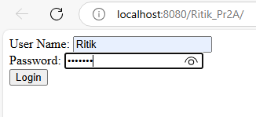

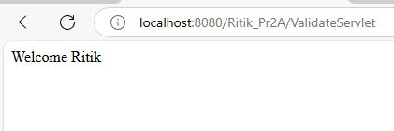

2B) Create a servlet that uses Cookies to store the number of times a user has visited servlet.

<html>
<head><title>Cookie Demo</title></head>
<body>
<form action="count1" >
Enter Your Name <input type="text" name="t1"><br>
<input type="submit" value="Click to Enter ">
</form>
</body>
</html>

package count;
import java.io.IOException;
import java.io.PrintWriter;
import javax.servlet.ServletException;
import javax.servlet.http.HttpServlet;
import javax.servlet.http.HttpServletRequest;
import javax.servlet.http.HttpServletResponse;
import javax.servlet.http.Cookie;

public class count1 extends HttpServlet {
static int count = 0;

@Override
protected void doGet(HttpServletRequest request, HttpServletResponse response)
throws ServletException, IOException {
response.setContentType("text/html;charset=UTF-8");
PrintWriter out = response.getWriter();
String name = request.getParameter("t1");

// Get cookies from the request
Cookie[] cookies = request.getCookies();
Cookie visitCookie = null;
int visitCount = 0;

// Check if "count" cookie already exists
if (cookies != null) {
for (Cookie cookie : cookies) {
if (cookie.getName().equals("count")) {
visitCookie = cookie;
visitCount = Integer.parseInt(cookie.getValue());
}
}
}

// If cookie is null, this is the first visit, so set a new cookie
if (visitCookie == null) {
out.println("Welcome, " + name + "! This is your first visit.");
visitCount = 1;
visitCookie = new Cookie("count", String.valueOf(visitCount));
} else {
visitCount++;
out.println("Welcome back, " + name + "! You have visited this page " + visitCount + " times.");
visitCookie.setValue(String.valueOf(visitCount));
}

// Add/update the cookie in the response
response.addCookie(visitCookie);
}
}

OUTPUT:

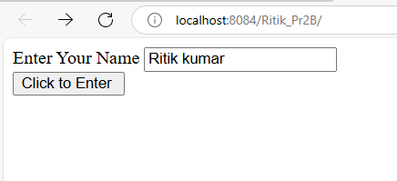

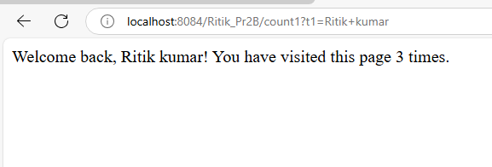
2C) Create a servlet demonstrating the use of session creation and destruction. Also check whether the user has visited this page first time or has visited earlier also using sessions.

CalculationVisitServlet.java
index.html
<html>
<head><title>Session Demo</title></head>
<form action="Page1" method="get" >
Enter User ID <input type="text" name="txtName"><br>
<input type="reset" ><input type="submit" >
</form>
</html>
Page1.java
import java.io.IOException;
import java.io.PrintWriter;
import javax.servlet.ServletException;
import javax.servlet.http.HttpServlet;
import javax.servlet.http.HttpServletRequest;
import javax.servlet.http.HttpServletResponse;
import javax.servlet.http.HttpSession;
public class Page1 extends HttpServlet {
public void doGet(HttpServletRequest request, HttpServletResponse response)
throws ServletException, IOException {
response.setContentType("text/html;charset=UTF-8");
PrintWriter out = response.getWriter();
out.println("<html><head><title>Servlet Page1</title></head>");
HttpSession hs = request.getSession(true);
if(hs.isNew()){
out.println("<body bgcolor=yellow>");
String name = request.getParameter("txtName");
hs.setAttribute("uname", name);
hs.setAttribute("visit", "1");
out.println("<h1>Welcome First Time</h1>");
}
else{
out.println("<h1>Welcome Again</h1>");
int visit = Integer.parseInt((String)hs.getAttribute("visit"))+1;
out.println("<h1>You Visited "+visit+"Times</h1>");
hs.setAttribute("visit", ""+visit);
}
out.println("<h1>Your Session ID "+hs.getId()+"</h1>");
out.println("<h1>You Logged in at "+new java.util.Date(hs.getCreationTime())+"</h1>");
out.println("<h1><a href=Page2>Click for Page 2 </a></h1>");
out.println("<h1><a href=LogoutServlet>Click to Terminate Session </a></h1>");
out.println("</body>");
out.println("</html>");
}
}
Page2.java
import java.io.IOException;
import java.io.PrintWriter;
import javax.servlet.ServletException;
import javax.servlet.http.HttpServlet;
import javax.servlet.http.HttpServletRequest;
import javax.servlet.http.HttpServletResponse;
import javax.servlet.http.HttpSession;
public class Page2 extends HttpServlet {
public void doGet(HttpServletRequest request, HttpServletResponse response)
throws ServletException, IOException {
response.setContentType("text/html;charset=UTF-8");
PrintWriter out = response.getWriter();
out.println("<html><head><title>Servlet Page2</title></head>");
HttpSession hs = request.getSession(false);
out.println("<h1>Welcome Again on Page No. 2</h1>");
int visit = Integer.parseInt((String)hs.getAttribute("visit"))+1;
out.println("<h1>You Visited "+visit+"Times</h1>");
hs.setAttribute("visit", ""+visit);
out.println("<h1>Your Session ID "+hs.getId()+"</h1>");
out.println("<h1>You Logged in at "+new java.util.Date(hs.getCreationTime())+"</h1>");
out.println("<h1><a href=Page1>Click for Page 1 </a></h1>");
out.println("<h1><a href=LogoutServlet>Click for Terminate Session </a></h1>");
out.println("</body>");
out.println("</html>");
}
}

logoutservlet.java

import java.io.IOException;
import java.io.PrintWriter;
import javax.servlet.ServletException;
import javax.servlet.http.HttpServlet;
import javax.servlet.http.HttpServletRequest;
import javax.servlet.http.HttpServletResponse;

public class LogoutServlet extends HttpServlet {
public void doGet(HttpServletRequest request, HttpServletResponse response)
throws ServletException, IOException {
response.setContentType("text/html;charset=UTF-8");
PrintWriter out = response.getWriter();
out.println("<html><head><title>Servlet LogoutServlet</title></head>");
out.println("<body>");
javax.servlet.http.HttpSession hs = request.getSession();
if(hs != null) hs.invalidate();
out.println("<h1>You are Logged out now........</h1>");
out.println("</body>");
out.println("</html>");
}
}

OUTPUT:

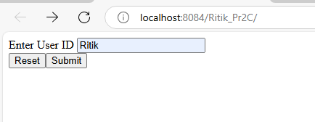

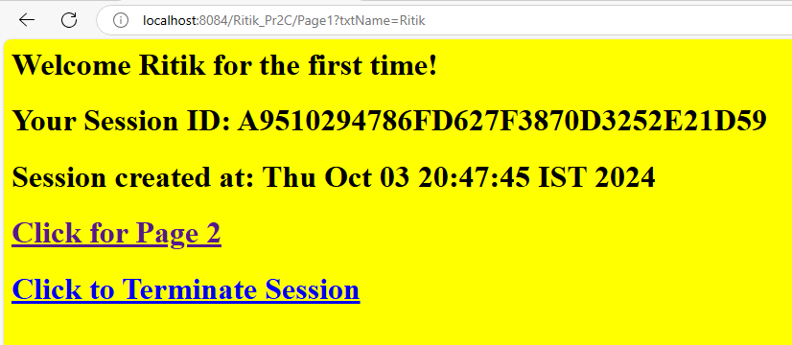
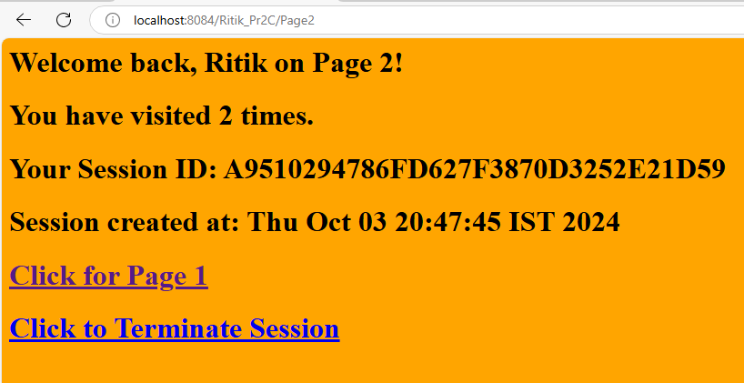

PRACTICAL NO: 3

3 A) Create a Servlet application to upload and download a file.

Uploading a file
Index.html
<html>
<body>
<form action="FileUploadServlet" method="post" enctype="multipart/form-data">
Select File to Upload:<input type="file" name="file" id="file">
Destination <input type="text" value="" name="destination">
<br>
<input type="submit" value="Upload file" name="upload" id="upload">
</form>
</body>
</html>

FileUploadServlet.java

import java.io.*;
import javax.servlet.*;
import javax.servlet.annotation.MultipartConfig;
import javax.servlet.http.*;
@MultipartConfig
public class FileUploadServlet extends HttpServlet {
public void doPost(HttpServletRequest req,HttpServletResponse res) throws ServletException, IOException
{
res.setContentType("text/html");
PrintWriter out = res.getWriter();
String path=req.getParameter("destination");
Part filePart=req.getPart("file");
String filename=filePart.getSubmittedFileName().toString();
out.print("<br><br><hr> file name: "+filename);
OutputStream os=null;
InputStream is=null;
try {
os=new FileOutputStream(new File(path+File.separator+filename));
is=filePart.getInputStream();
int read=0;
while ((read = is.read()) != -1) {
os.write(read);
}
out.println("<br>file uploaded sucessfully...!!!");
}
catch(FileNotFoundException e){out.print(e);}
}
}
Downloading a file
Index.html

<html>
<head>
<title>File Download Application</title>
</head>
<body>
<h1>File Download Application</h1>
Click <a href="DownloadServlet?filename=SampleChapter.pdf">Sample Chapter</a>
<br/><br/>
Click <a href="DownloadServlet?filename=TOC.pdf">Table Of Contents</a>
</body>
</html>

DownloadServlet.java

import java.io.*;
import javax.servlet.*;
import javax.servlet.http.*;

public class DownloadServlet extends HttpServlet {
public void doGet(HttpServletRequest request, HttpServletResponse response)
throws ServletException, IOException {

response.setContentType("APPLICATION/OCTET-STREAM");
String filename = request.getParameter("filename");
ServletContext context = getServletContext();
InputStream is = context.getResourceAsStream("/" + filename);
ServletOutputStream os = response.getOutputStream();

response.setHeader("Content-Disposition", "attachment; filename=\"" + filename + "\"");

int i;
byte[] b = new byte[1024];
while ((i = is.read(b)) != -1) {
os.write(b, 0, i); // Specify the number of bytes read
}

is.close();
os.close();
}
}
OUTPUT:

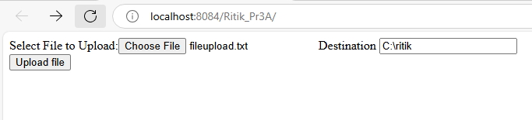

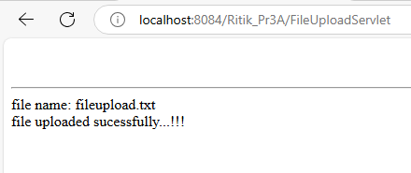

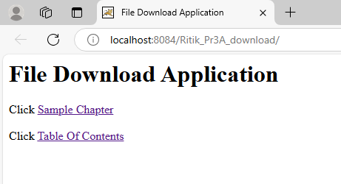

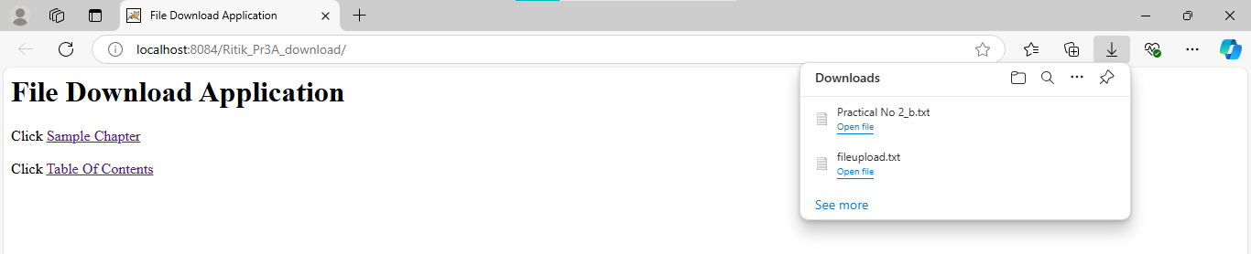

3 B) Develop Simple Servlet Question Answer Application using Database.
QueAnsDBServlet.java

<html>
<head>
<title>Quiz Application</title>
</head>
<body>
<h1>Welcome to the Quiz Servlet</h1>
<h1><a href="QuizServlet">CLICK TO START QUIZ</a></h1>
</body>
</html>
QueAnsDBServlet.java
package dbapp;
import javax.servlet.*;
import javax.servlet.http.*;
import java.io.*;
import java.sql.*;

public class QueAnsDBServlet extends HttpServlet {
public void doGet(HttpServletRequest request, HttpServletResponse response) throws ServletException, IOException {
response.setContentType("text/html");
PrintWriter out = response.getWriter();
try {
out.print("<html><body><br>");
out.println("<form method='post' action='Marks'>");
Class.forName("com.mysql.jdbc.Driver");
Connection con = DriverManager.getConnection("jdbc:mysql://localhost/qadb", "root", "root");
Statement st = con.createStatement();
String sql = "select * from quiz";
ResultSet rs = st.executeQuery(sql);
int i = 0;
out.print("<center>Online Exam</center>");
while (rs.next()) {
i++;
out.print("<br><br><hr>" + rs.getInt(1) + " ");
out.print(rs.getString(2));
out.print("<br><input type=radio name='" + i + "' value='" + rs.getString(3) + "'>" + rs.getString(3));
out.print("<br><input type=radio name='" + i + "' value='" + rs.getString(4) + "'>" + rs.getString(4));
out.print("<br><input type=radio name='" + i + "' value='" + rs.getString(5) + "'>" + rs.getString(5));
out.print("<br><input type=radio name='" + i + "' value='" + rs.getString(6) + "'>" + rs.getString(6));
String ans = "ans" + i;
out.println("<br><input type=hidden name='" + ans + "' value='" + rs.getString(7) + "'>");
}
out.println("<br><input type=hidden name='total' value='" + i + "'>");
out.println("<input type='submit' value='submit'>");
out.println("</form>");
out.print("</body></html>");
} catch (Exception e) {
out.println("ERROR " + e.getMessage());
}
}
}
Marks.java
package dbapp;
import javax.servlet.*;
import javax.servlet.http.*;
import java.io.*;

public class Marks extends HttpServlet {
public void doPost(HttpServletRequest request, HttpServletResponse response) throws ServletException, IOException {
response.setContentType("text/html");
PrintWriter out = response.getWriter();
try {
out.print("<html><body>");
int total = Integer.parseInt(request.getParameter("total"));
int marks = 0;
for (int i = 1; i <= total; i++) {
String sel = request.getParameter(String.valueOf(i));
String ans = request.getParameter("ans" + i);

// Debugging output
System.out.println("Selected: " + sel + ", Correct: " + ans);

if (sel != null && ans != null && sel.equals(ans)) {
marks++;
}
}
out.println("Total Marks: " + marks + " out of " + total);
out.print("</body></html>");
} catch (Exception e) {
out.println("ERROR " + e.getMessage());
} }}

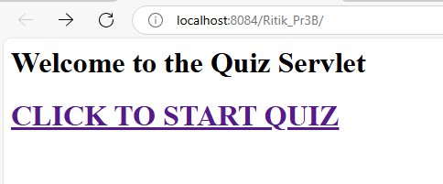
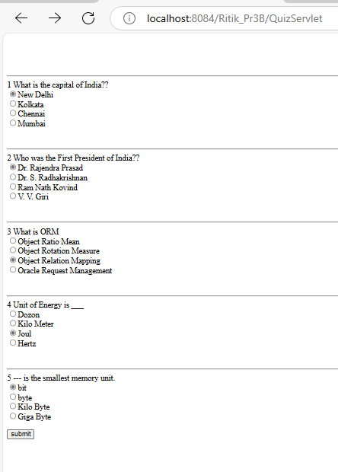
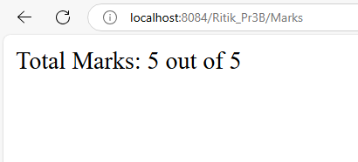
3 C) Create simple Servlet application to demonstrate Non-Blocking Read Operation.

Index.html
<html>
<head>
<title>Non Blocking IO</title>
<meta charset="UTF-8">
<meta http-equiv="Refresh" content="0; URL=NonBlockingServlet">
</head>
<body>
</body>
</html>

NonBlockingServlet.java
import java.io.*;
import java.net.*;
import javax.servlet.*;
import javax.servlet.http.*;
public class NonBlockingServlet extends HttpServlet {
protected void service(HttpServletRequest request, HttpServletResponse response)
throws ServletException, IOException {
response.setContentType("text/html;charset=UTF-8");
try (PrintWriter out = response.getWriter()) {
out.println("<h1>FileReader</h1>");
String filename="/WEB-INF/booklist.txt";
ServletContext c=getServletContext();
InputStream in=c.getResourceAsStream(filename);
String path="http://"+request.getServerName()+":"+request.getServerPort()+request.getContextPath()+"/ReadingNonBloclingServlet";
URL url=new URL(path);
HttpURLConnection conn=(HttpURLConnection)url.openConnection();
conn.setChunkedStreamingMode(2);
conn.setDoOutput(true);
conn.connect();
if(in!=null)
{
InputStreamReader inr=new InputStreamReader(in);
BufferedReader br = new BufferedReader(inr);
String text="";
System.out.println("Reading started....");
BufferedWriter bw=new BufferedWriter(new OutputStreamWriter(conn.getOutputStream()));
while((text=br.readLine())!=null){
out.print(text+"<br>");
try{
Thread.sleep(1000);
out.flush();
}
catch(InterruptedException ex){}
}out.print("reading completed....");
bw.flush();
bw.close();
}
}
}
}

ReadingListener.java
import java.io.IOException;
import java.util.logging.Level;
import java.util.logging.Logger;
import javax.servlet.AsyncContext;
import javax.servlet.ReadListener;
import javax.servlet.ServletInputStream;
public class ReadingListener implements ReadListener
{
private ServletInputStream input = null;
private AsyncContext ac = null;
ReadingListener(ServletInputStream in, AsyncContext c) {
input = in;
ac = c;
}
@Override
public void onDataAvailable() throws IOException {
}
public void onAllDataRead() throws IOException {
ac.complete();
}
public void onError(final Throwable t) {
ac.complete();
t.printStackTrace();
}
}
ReadingNonBlockingServlet.java
import java.io.IOException;
import java.io.PrintWriter;
import javax.servlet.AsyncContext;
import javax.servlet.ServletException;
import javax.servlet.ServletInputStream;
import javax.servlet.annotation.WebServlet;
import javax.servlet.http.HttpServlet;
import javax.servlet.http.HttpServletRequest;
import javax.servlet.http.HttpServletResponse;

@WebServlet (name = "ReadingNonBlockingServlet", urlPatterns = {"/ReadingNonBlockingServlet"},asyncSupported = true )
public class ReadingNonBlockingServlet extends HttpServlet {
@Override
protected void service(HttpServletRequest request, HttpServletResponse response)
throws ServletException, IOException {
response.setContentType("text/html");
AsyncContext ac = request.startAsync();
ServletInputStream in=request.getInputStream();
in.setReadListener(new ReadingListener(in,ac));
}
}

OUTPUT:

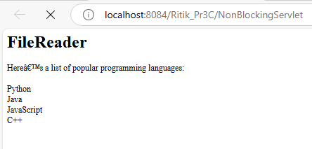

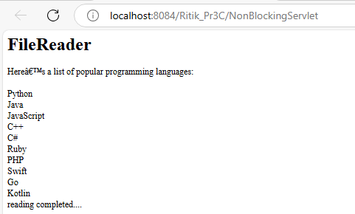
PRACTICAL NO: 4

4 A) Develop a simple JSP application to display values obtained from the use of intrinsic objects of various types.

index.jsp
<html>
<body>
<form action="implicitObjectEx.jsp">
Enter your name: <input type="text" name="myname"><br>
Enter your email id: <input type="text" name="mymailid"><br>
<input type="submit" value="submit">
</form>
</body>
</html>

implicitObjectEx.jsp

<%@page contentType="text/html" pageEncoding="UTF-8"%>
<html>
<head>
<title>JSP Page</title>
</head>
<body>
<h1>Use of Intrinsic Objects in JSP</h1>

<h1>Request Object</h1>
Query String: <%= request.getQueryString() %><br>
Context Path: <%= request.getContextPath() %><br>
Remote Host: <%= request.getRemoteHost() %><br>

<h1>Response Object</h1>
Character Encoding Type: <%= response.getCharacterEncoding() %><br>
Content Type: <%= response.getContentType() %><br>
Locale: <%= response.getLocale() %><br>

<h1>Session Object</h1>
ID: <%= session.getId() %><br>
Creation Time: <%= new java.util.Date(session.getCreationTime()) %><br>
Last Access Time: <%= new java.util.Date(session.getLastAccessedTime()) %><br>
</body>
</html>

OUTPUT:

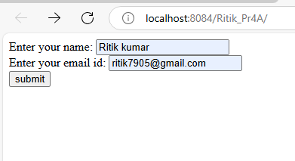

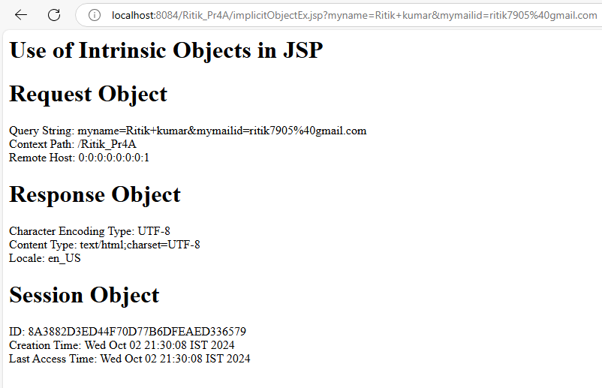

4 B) Develop a simple JSP application to pass values from one page to another with validations. (Name-txt, age-txt, hobbies-checkbox, email-txt, gender-radio button).

Index.html

<html><head><title>User Information Paage</title>
</head>
<body>
<form action="Validate.jsp">
Enter Your Name<input type="text" name="name" ><br>
Enter Your Age<input type="text" name="age" ><br>
Select Hobbies
<input type="checkbox" name="hob" value="Singing">Singing
<input type="checkbox" name="hob" value="Reading">Reading Books
<input type="checkbox" name="hob" value="Football">Playing Football<br>
Enter E-mail<input type="text" name="email" ><br>
Select Gender
<input type="radio" name="gender" value="male">Male
<input type="radio" name="gender" value="female">Female
<input type="radio" name="gender" value="other">Other<br>
<input type="hidden" name="error" value="">
<input type="submit" value="Submit Form">
</form>
</body>
</html>

CheckerBean.java

package mypack;

public class CheckerBean {
private String name, age, email, gender;
private String[] hob; // Changed to String array
private String error;

public CheckerBean() {
error = "";
}

// Setters
public void setName(String n) { name = n; }
public void setAge(String a) { age = a; }
public void setHob(String[] h) { hob = h; } // Accept an array for hobbies
public void setEmail(String e) { email = e; }
public void setGender(String g) { gender = g; }
public void setError(String e) { error = e; }

// Getters
public String getName() { return name; }
public String getAge() { return age; }
public String[] getHob() { return hob; } // Return hobbies as array
public String getEmail() { return email; }
public String getGender() { return gender; }
public String getError() { return error; }

public boolean validate() {
boolean res = true;

if (name == null || name.trim().equals("")) {
error += "<br>Enter First Name";
res = false;
}

if (age == null || age.length() > 2) {
error += "<br>Age Invalid";
res = false;
}

// Add more validations if necessary
return res;
}
}

Validate.jsp

<%@page contentType="text/html" pageEncoding="UTF-8" import="mypack.*" %>
<html>
<head>
<title>JSP Page</title>
</head>
<body>
<h1>Validation Page</h1>
<jsp:useBean id="obj" scope="request" class="mypack.CheckerBean">
<jsp:setProperty name="obj" property="*"/>
</jsp:useBean>

<% if (obj.validate()) { %>
<jsp:forward page="successful.jsp"/>
<% } else { %>
<jsp:include page="index.html"/>
<% } %>
<%= obj.getError() %>
</body>
</html>

OUTPUT:

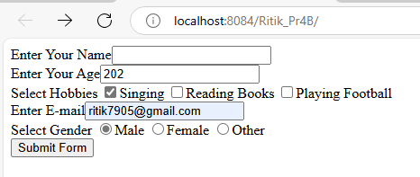

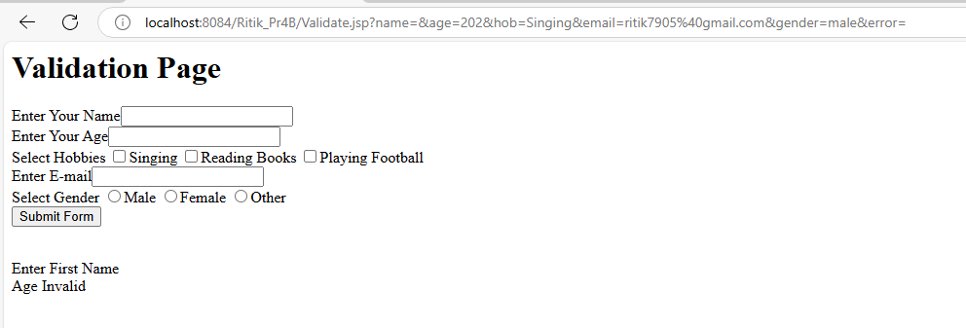

C) Create a registration and login JSP application to register and authenticate the user based on username and password using JDBC.

Index.html
<html><head><title>New User Registration Page</title></head>
<body>
<form action="Register.jsp" >
<h1> New User Registration Page</h1>
Enter User Name <input type="text" name="txtName" ><br>
Enter Password <input type="password" name="txtPass1" ><br>
Re-Enter Password<input type="password" name="txtPass2" ><br>
Enter Email<input type="text" name="txtEmail" ><br>
Enter Country Name <input type="text" name="txtCon" ><br>
<input type="reset" ><input type="submit" value="REGISTER" >
</form>
</body>
</html>
Registration.jsp
<%@page contentType="text/html" import="java.sql.*"%>
<html><body>
<h1>Registration JSP Page</h1>
<%
String uname = request.getParameter("txtName");
String pass1 = request.getParameter("txtPass1");
String pass2 = request.getParameter("txtPass2");
String email = request.getParameter("txtEmail");
String ctry = request.getParameter("txtCon");
if (pass1.equals(pass2)) {
try {
Class.forName("com.mysql.jdbc.Driver");
Connection con = DriverManager.getConnection("jdbc:mysql://localhost:3306/logindb", "root", "root");
PreparedStatement stmt = con.prepareStatement("insert into user values (?,?,?,?,?)");
stmt.setString(1, uname);
stmt.setString(2, pass1);
stmt.setString(3, pass1);
stmt.setString(4, email);
stmt.setString(5, ctry);

int row = stmt.executeUpdate();
if (row == 1) {
out.println("Registration Successful");
} else {
out.println("Registration FAIL !!!!");
%><jsp:include page="Register.html" ></jsp:include>
<%
}
} catch (Exception e) {
out.println(e);
}
} else {
out.println("<h1>Password Mismatch</h1>");
%>
<jsp:include page="Register.html" ></jsp:include>
<% }
%>
</body>
</html>
Login.html
<html>
<body>
<h1>Login Page</h1>
<form action="Login.jsp" >
Enter User Name <input type="text" name="txtName" ><br>
Enter Password <input type="password" name="txtPass" ><br>
<input type="reset" ><input type="submit" value="LOGIN" >
</form>
</body>
</html>
Login.jsp
<%@page contentType="text/html" import="java.sql.*"%>
<html><body>
<h1>Registration JSP Page</h1>
<%
String uname = request.getParameter("txtName");
String pass = request.getParameter("txtPass");
try {
Class.forName("com.mysql.jdbc.Driver");
Connection con = DriverManager.getConnection("jdbc:mysql://localhost:3306/logindb", "root", "root");
PreparedStatement stmt = con.prepareStatement("select password from user where username=?");
stmt.setString(1, uname);
ResultSet rs = stmt.executeQuery();
if (rs.next()) {
if (pass.equals(rs.getString(1))) {
out.println("<h1> LOGIN SUCCESSFULLL </h1>");
}
} else {
out.println("<h1>User Name not exist !!!!!</h1>");
%>
<jsp:include page="Register.html" ></jsp:include>
<%
}
} catch (Exception e) {
out.println(e);
}
%>
</body></html>

OUTPUT;

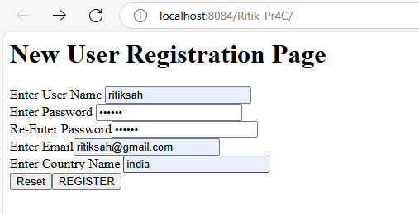

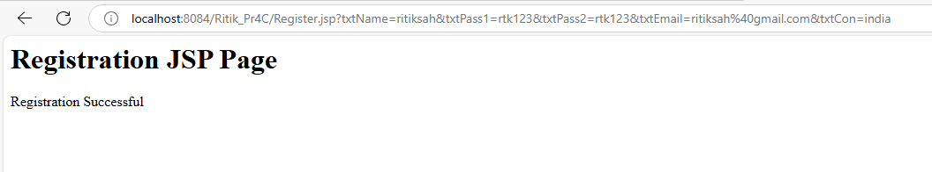

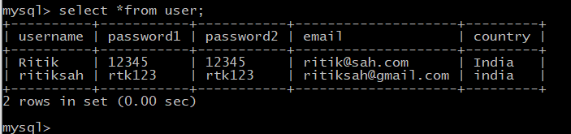
PRACTICAL NO: 5

A) Create an html page with fields, eno, name, age, desg, salary. Now on submit this data to a JSP page which will update the employee table of database with matching eno.

<html>
<body>
<form action="UpdateEmp.jsp" >
Enter Employee Number<input type="text" name="txtEno" ><br>
Enter Name<input type="text" name="txtName" ><br>
Enter age<input type="text" name="txtAge" ><br>
Enter Salary<input type="text" name="txtSal" ><br>
<input type="reset" ><input type="submit">
</form>
</body>
</html>

<%@page contentType="text/html" import="java.sql.*" %>
<html><body>
<h1>Employee Record Update</h1>
<%
String eno=request.getParameter("txtEno");
String name=request.getParameter("txtName");
String age = request.getParameter("txtAge");
String sal = request.getParameter("txtSal");
try{
Class.forName("com.mysql.jdbc.Driver");
Connection con = DriverManager.getConnection("jdbc:mysql://localhost:3306/logindb","root","root");
PreparedStatement stmt = con.prepareStatement("select * from emp where empid=?");
stmt.setString(1, eno);
ResultSet rs = stmt.executeQuery();
if(rs.next()){
out.println("<h1>~~~ Employee "+name+" Exist ~~~ </h1>");
PreparedStatement pst1= con.prepareStatement("update emp set salary=? where empid=?");
PreparedStatement pst2= con.prepareStatement("update emp set age=? where empid=?");
pst1.setString(1, sal); pst1.setString(2, eno);
pst2.setString(1, age); pst2.setString(2, eno);
pst1.executeUpdate(); pst2.executeUpdate();
}
else{
out.println("<h1>Employee Record not exist !!!!!</h1>");
}
}catch(Exception e){out.println(e);}
%></body></html>
OUTPUT:

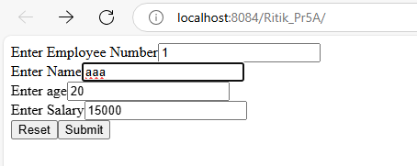

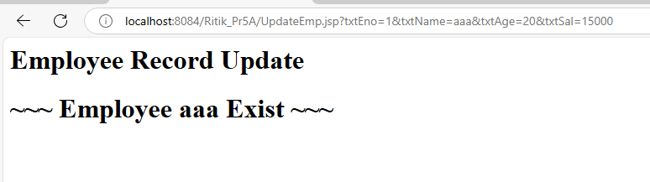

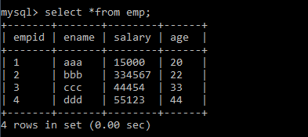

B) Create a JSP page to demonstrate the use of Expression language.

<%@ page contentType="text/html;charset=UTF-8" language="java" %>
<!DOCTYPE html>
<html>
<head>
<meta charset="UTF-8">
<title>Expression Language Demo</title>
</head>
<body>

<h2>Expression Language (EL) in JSP</h2>

<!-- Accessing a simple variable using EL -->
<h3>1. Simple Variable</h3>
<%-- Setting an attribute in the request scope --%>
<%
request.setAttribute("userName", "Ritik Sah");
%>
<p>Welcome, ${userName}!</p>

<!-- Accessing session-scoped variable using EL -->
<h3>2. Session Scope Variable</h3>
<%-- Setting an attribute in the session scope --%>
<%
session.setAttribute("sessionVariable", "Session Value");
%>
<p>Session Value: ${sessionVariable}</p>

<!-- Accessing application-scoped variable using EL -->
<h3>3. Application Scope Variable</h3>
<%-- Setting an attribute in the application scope --%>
<%
application.setAttribute("appVariable", "Application Scope Value");
%>
<p>Application Value: ${applicationScope.appVariable}</p>

<!-- Performing arithmetic operations using EL -->
<h3>4. Arithmetic Operations</h3>
<p>10 + 20 = ${10 + 20}</p>
<p>30 * 2 = ${30 * 2}</p>

<!-- Logical operators in EL -->
<h3>5. Logical Operators</h3>
<p>Is 10 greater than 5? ${10 > 5}</p>

<!-- Ternary operator in EL -->
<h3>6. Ternary Operator</h3>
<p>${userName == 'Ritik Sah' ? 'Hello Ritik!' : 'Hello Guest!'}</p>

</body>
</html>

OUTOUT:

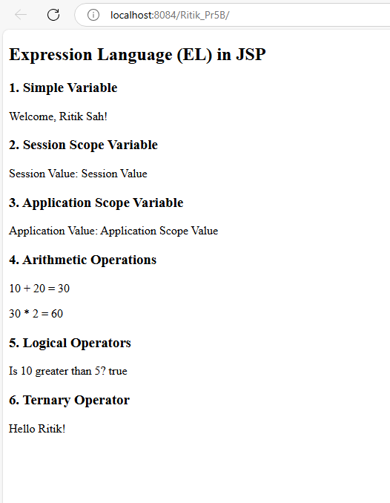
C) Create a JSP application to demonstrate the use of JSTL.

<%@ page contentType="text/html;charset=UTF-8" language="java" %>
<%@ taglib uri="http://java.sun.com/jsp/jstl/core" prefix="c" %>
<%@ taglib uri="http://java.sun.com/jsp/jstl/fmt" prefix="fmt" %>
<%@ page import="java.util.Date" %>

<html>
<head>
<title>JSTL Example</title>
</head>
<body>
<h2>User List</h2>
<!-- Creating a list of users -->
<c:set var="users" value="${['Alice', 'Bob', 'Charlie', 'David']}" />

<ul>
<!-- Iterating through the list of users -->
<c:forEach var="user" items="${users}">
<li>${user}</li>
</c:forEach>
</ul>
<h3>Current Date and Time:</h3>
<%
// Create a Date object to get the current date and time
Date currentDate = new Date();
request.setAttribute("currentDate", currentDate);
%>
<fmt:formatDate value="${currentDate}" pattern="yyyy-MM-dd HH:mm:ss" />
</body>
</html>
OUTPUT:
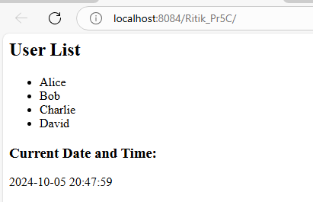
PRACTICAL NO: 6

A) Create a Currency Converter application using EJB.
Index.html
<html><head><title>Currency Converter</title></head>
<body>
<form action="CCServlet" >
Enter Amount <input type="text" name="amt"><br>
Select Conversion Type
<input type="radio" name="type" value="r2d" checked>Rupees to Dollar
<input type="radio" name="type" value="d2r" >Dollor to Rupees<br>
<input type="reset" ><input type="submit" value="CONVERT" >
</form>
</body>
</html>
CCServlet.java
package mypacks;
import java.io.*;
import javax.servlet.*;
import javax.servlet.http.*;
import javax.ejb.EJB;
import mybeans.CCBean;
public class CCServlet extends HttpServlet {
@EJB CCBean obj;
public void doGet(HttpServletRequest request, HttpServletResponse response)
throws ServletException, IOException {
response.setContentType("text/html;charset=UTF-8");
PrintWriter out = response.getWriter();
double amt = Double.parseDouble(request.getParameter("amt"));
if(request.getParameter("type").equals("r2d"))
{
out.println("<h1>"+amt+ " Rupees = "+obj.r2Dollor(amt)+" Dollors</h1>");
}
if(request.getParameter("type").equals("d2r"))
{
out.println("<h1>"+amt+ " Dollors = "+obj.d2Rupees(amt)+" Rupees</h1>");
}}}
CCBean.java
package mybeans;
import javax.ejb.Stateless;
@Stateless
public class CCBean {
public CCBean(){}
public double r2Dollor(double r){ return r/82.53; }
public double d2Rupees(double d){ return d*82.53; }
}
OUTPUT:
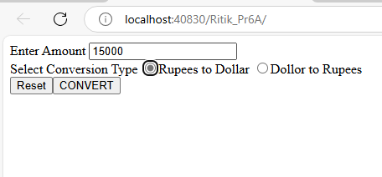\

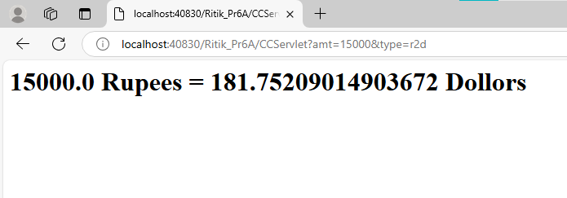

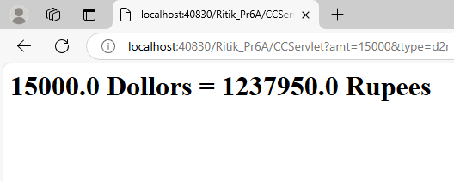

B) Develop a Simple Room Reservation System Application Using EJB.

Index.html
<!DOCTYPE html>
<html>
<head>
<title>Room Reservation</title>
</head>
<body>
<h2>Room Reservation Form</h2>
<form action="RBServlet" method="GET">
<label>Select a room type:</label><br>
<input type="radio" name="txtType" value="Delux" required> Delux<br>
<input type="radio" name="txtType" value="Super Delux"> Super Delux<br>
<input type="radio" name="txtType" value="Suit"> Suit<br><br>

<label>Enter Your Name:</label><br>
<input type="text" name="txtCust" required><br><br>

<label>Enter Mobile No.:</label><br>
<input type="text" name="txtMob" required pattern="[0-9]{10}"><br><br>

<input type="reset" value="Reset">
<input type="submit" value="Book Room">
</form>
</body>
</html>

RRbean.java
package mybeans;

import javax.ejb.Stateless;
import java.sql.*;

@Stateless
public class RRBean {

public RRBean() {}

public String roomBook(String rt, String cn, String cm) {
String msg = "";
Connection con = null;
PreparedStatement pst = null;
ResultSet rs = null;

try {
// Load MySQL JDBC Driver
Class.forName("com.mysql.cj.jdbc.Driver");
// Establish connection
con = DriverManager.getConnection("jdbc:mysql://localhost:3306/roomdb", "root", "root");

// Check for available room
String query = "SELECT * FROM roombook WHERE RoomType=? AND status='Not Booked'";
pst = con.prepareStatement(query);
pst.setString(1, rt);
rs = pst.executeQuery();

if (rs.next()) {
String rno = rs.getString("RoomId");

// Update room details (customer, mobile, status)
PreparedStatement stm1 = con.prepareStatement("UPDATE roombook SET cust=?, mob=?, status='Booked' WHERE RoomId=?");
stm1.setString(1, cn);
stm1.setString(2, cm);
stm1.setString(3, rno);

stm1.executeUpdate();

msg = "Room " + rno + " successfully booked!<br>Charges: " + rs.getString("charges");
} else {
msg = "No rooms of type " + rt + " are available right now.";
}

} catch (Exception e) {
msg = "Error: " + e.getMessage();
} finally {
// Close resources
try {
if (rs != null) rs.close();
if (pst != null) pst.close();
if (con != null) con.close();
} catch (SQLException e) {
e.printStackTrace();
}
}
return msg;
}
}
RBServlet.java
package mypack;

import java.io.*;
import javax.servlet.*;
import javax.servlet.http.*;
import javax.ejb.EJB;
import mybeans.RRBean;

public class RBServlet extends HttpServlet {
@EJB
RRBean obj;

public void doGet(HttpServletRequest request, HttpServletResponse response)
throws ServletException, IOException {
response.setContentType("text/html");
PrintWriter out = response.getWriter();

// Get parameters from form
String rt = request.getParameter("txtType");
String cn = request.getParameter("txtCust");
String cm = request.getParameter("txtMob");

// Call EJB method to book room
String msg = obj.roomBook(rt, cn, cm);
out.println("<html><body>");
out.println("<h3>" + msg + "</h3>");
out.println("</body></html>");
}
}

OUTPUT:

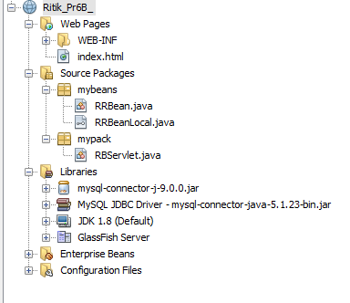
C) Develop simple shopping cart application using EJB [Stateful Session Bean].

PRACTICAL NO: 7

A) Develop simple EJB application to demonstrate Servlet Hit count using Singleton Session Beans.

Index.html
<html>
<head>
<title>TODO supply a title</title>
<meta charset="UTF-8">
<meta name="viewport" content="width=device-width, initial-scale=1.0">
<meta http-equiv="Refresh" content="0; URL=ServletClient">
</head>
<body>
<div>TODO write content</div>
</body>
</html>

CountServletHitsBean.java

package ejb;

import javax.ejb.Singleton;

@Singleton
public class CountServletHitsBean {

private int hitCount;

public synchronized int getCount() {
return hitCount++;
}
}

ServletClient.java

package servlet;
import ejb.CountServletHitsBean;
import java.io.*;
import javax.ejb.EJB;
import javax.servlet.ServletException;
import javax.servlet.annotation.WebServlet;
import javax.servlet.http.*;
@WebServlet(name = "ServletClient", urlPatterns = {"/ServletClient"})
public class ServletClient extends HttpServlet {
@EJB CountServletHitsBean obj;
@Override
protected void service (HttpServletRequest req, HttpServletResponse res) throws ServletException, IOException
{
res.setContentType("text/html");
PrintWriter out=res.getWriter();
out.print("<b>Number of times this Servlet is accessed </b>: "+obj.getCount());
}
}

OUTPUT:

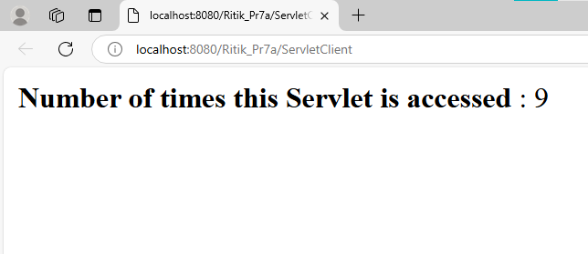

B) Develop simple visitor Statistics application using Message Driven Bean [Stateless Session Bean].
Index.jsp
<%@page import="javax.jms.JMSException"%>
<%@page import="javax.naming.InitialContext"%>
<%@page import="javax.jms.Connection"%>
<%@page import="javax.jms.TextMessage"%>
<%@page import="javax.jms.MessageProducer"%>
<%@page import="javax.jms.Session"%>
<%@page import="javax.jms.Queue"%>
<%@page import="javax.jms.ConnectionFactory"%>
<%@page contentType="text/html" pageEncoding="UTF-8"%>
<!DOCTYPE html>
<%!
private static ConnectionFactory connectionFactory;
private static Queue queue;
Connection connection = null;
Session mySession = null;
MessageProducer messageProducer = null;
TextMessage message = null;
%>
<html>
<head>
<meta http-equiv="Content-Type" content="text/html; charset=UTF-8">
<title>JSP Page</title>
</head>
<body>
Welcome to My Home Page
<%
try {
InitialContext ic = new InitialContext();
queue = (Queue) ic.lookup("jms/Queue");
connectionFactory = (ConnectionFactory) ic.lookup("jms/QueueFactory");
connection = connectionFactory.createConnection();
mySession = connection.createSession(false, Session.AUTO_ACKNOWLEDGE);
messageProducer = mySession.createProducer(queue);
message = mySession.createTextMessage();
message.setText(request.getRemoteAddr());
messageProducer.send(message);
} catch (JMSException e) {
System.out.println("Exception Occoured " + e.toString());
}
%>
</body>
</html>

VisitorStatBean.java
package ejb;
import java.sql.*;
import javax.annotation.PostConstruct;
import javax.annotation.PreDestroy;
import javax.ejb.Stateless;
@Stateless
public class VisitorStatBean {
private Connection conn = null;
private ResultSet rs;
private Statement st = null;
private String query = null;

@PostConstruct
public void connect() {
try {
Class.forName("com.mysql.jdbc.Driver").newInstance();
conn = DriverManager.getConnection("jdbc:mysql://localhost/visitorstat", "root", "tiger");
} catch (Exception e) {
System.err.println(e.getMessage());
}
}
@PreDestroy
public void disconnect() {
try {
conn.close();
} catch (Exception e) {
System.err.println(e.getMessage());
}
}
public void addVisitor(String host) {
try {
st = conn.createStatement();
query = "insert into userstat (hostname,visits) values ('" + host + "','1')";
st.executeUpdate(query);
} catch (SQLException e) {
try {
st = conn.createStatement();
query = "update userstat set visits=visits+1 where hostname='" + host + "' ";
st.executeUpdate(query);
} catch (SQLException ex) {
System.err.println("Cannot Update" + e.getMessage());
}
}
}}
BasicMessageBean.java
package ejb;
import javax.annotation.Resource;
import javax.ejb.ActivationConfigProperty;
import javax.ejb.EJB;
import javax.ejb.MessageDriven;
import javax.ejb.MessageDrivenContext;
import javax.jms.JMSException;
import javax.jms.Message;
import javax.jms.MessageListener;
import javax.jms.TextMessage;
@MessageDriven(activationConfig = {
@ActivationConfigProperty(propertyName = "destinationLookup", propertyValue = "jms/Queue")
,
@ActivationConfigProperty(propertyName = "destinationType", propertyValue = "javax.jms.Queue")
})
public class BasicMessageBean implements MessageListener {
@EJB
VisitorStatBean vs;
@Resource
private MessageDrivenContext mdc;

public BasicMessageBean() {
}
@Override
public void onMessage(Message message) {
try {
if (message instanceof TextMessage) {
TextMessage msg = (TextMessage) message;
vs.addVisitor(msg.getText());
}
} catch (JMSException e) {
mdc.setRollbackOnly();
}}}
OUTPUT:

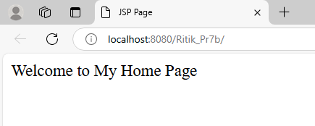
C) Develop simple Marks Entry Application to demonstrate accessing Database using EJB.
Index.jsp
<%@page import="ejb.MarksEntryBean"%>
<%@page import="javax.naming.InitialContext"%>
<%@page contentType="text/html" pageEncoding="UTF-8"%>
<!DOCTYPE html>
<%!
private static MarksEntryBean obj;
public void jspInit() {
try {
InitialContext ic = new InitialContext();
obj = (MarksEntryBean) ic.lookup("java:global/Ritik_Pr7C/MarksEntryBean");
} catch (Exception e) {
System.out.println(e);
}
}
%>
<%
if (request.getParameter("InsertMarks") != null) {
String sname;
int marks1, marks2, marks3;
sname = request.getParameter("sname");
marks1 = Integer.parseInt(request.getParameter("m1"));
marks2 = Integer.parseInt(request.getParameter("m2"));
marks3 = Integer.parseInt(request.getParameter("m3"));
obj.addMarks(sname, marks1, marks2, marks3);
out.print("Marks entered successfully..!!!!");
}
%>
<html>
<head>
<meta http-equiv="Content-Type" content="text/html; charset=UTF-8">
<title>JSP Page</title>
</head>
<body>
<h2>Enter Details</h2>
<form name="result" method="post">
Enter student's name: <input type='text' name="sname" /><br>
Enter subject 1 marks: <input type='text' name="m1" /><br>
Enter subject 2 marks: <input type='text' name="m2" /><br>
Enter subject 3 marks: <input type='text' name="m3" /><br>
<input type='submit' name="InsertMarks" /><br>
</form>
</body>
</html>
MarksEntryBean.java
package ejb;

import java.sql.*;
import javax.ejb.Stateful;

@Stateful
public class MarksEntryBean {

String sname;
int m1, m2, m3;
Connection con = null;
Statement st = null;
String query = "";

public void addMarks(String sname, int m1, int m2, int m3) {
try {
Class.forName("com.mysql.jdbc.Driver");
con = DriverManager.getConnection("jdbc:mysql://localhost:3306/marksdb", "root", "root");
st = con.createStatement();
query = "insert into marks (sname,marks1,marks2,marks3) values ('" + sname + "','" + m1 + "','" + m2 + "','" + m3 + "')";
st.executeUpdate(query);
System.out.print("Marks entered sucessfully!!");
} catch (Exception e) {
System.out.println(e);
}
}
}
OUTPUT:

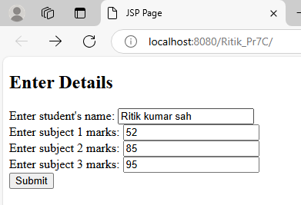
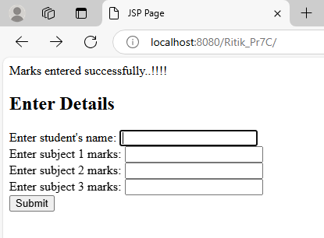

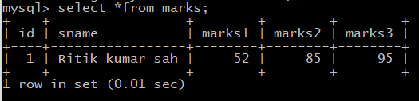

PRACTICAL NO: 8

A) Develop a simple Inventory Application Using JPA.

B) Develop a Guestbook Application Using JPA.

C) Create simple JPA application to store and retrieve Book details.<< similar to above example >>

PRACTICAL NO: 9

A) Develop a JPA Application to demonstrate use of ORM associations.

B) Develop a Hibernate application to store Feedback of Website Visitor in MySQL Database.

C) Develop a Hibernate application to store and retrieve employee details in MySQL Database. <<Similar to above appication>>

PRACTICAL NO: 10
A) Develop an application to demonstrate Hibernate One- To -One Mapping Using Annotation.

- Develop Hibernate application to enter and retrieve course details with ORM Mapping.

- Develop a five page web application site using any two or three Java EE Technologies.

